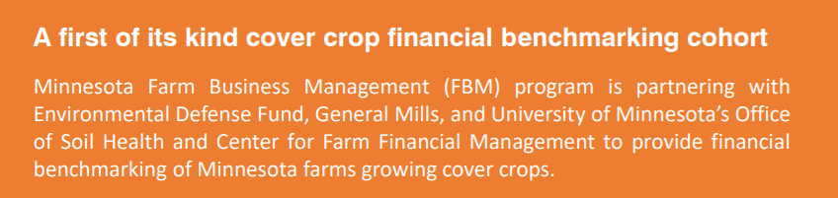

Frequently Asked Questions regarding new cover crop scholarship

When will applications open?

Applications will be open on Nov 1st, 2021. An example application was prematurely placed on the AgCentric Website, however it did not contain all the questions needed and wasn’t an approved method of obtaining student information by Minnesota State standards. Therefore, students and/or instructors will need to resubmit applications on November 1st, 2021.

How much scholarship am I eligible for when applying in November?

New to FBM students are eligible for $150/credit for a maximum of 5 credits for spring/summer semester 2022. Existing students are eligible for $100/credit for a maximum of 5 credits for spring/summer semester 2022.

Do they need to have a cover crop planted in 2021 to apply?

Yes, they need to have a fall planted cover crop in the ground in 2021 to be eligible for the scholarship. They should be tracking cover crop expenses on the Jan 1 2022 balance sheet and then will enterprise the cover crop acres and main crop acres in the 2022 analysis.

What crops can they plant after or into the cover crop?

Corn for Grain, Corn for Silage, Soybeans, Spring Wheat and Sugar beets

How many acres are needed to be considered a full field?

We request a minimum of 10 acres for a field to qualify, however that field must match the same acres of the main crop acres in the analysis. For example, if you have an 80-acre field and only plan on planting cover crops on 30 acres, you will need to track the cover crop expenses on the 30 acres and then make sure you have a matching 30-acre field of the main crop in the analysis.

Will I need to reapply in Summer/Fall of 2022 for the next round of scholarship?

Yes, but the application will be simplified for those existing students who have already been approved. This round will be for a full school year of scholarship, so maximum of 10 credits for the year instead of 5 credits for the semester.

Who can I contact for more information on the scholarship program?

Josh Tjosaas, MN State FBM Database lead can help answer some of the questions on the scholarship program and eligibility. Vincent Gauthier from EDF can answer questions on the program objectives. Their email contacts are included below

When will I be notified that my application has been reviewed?

Applications will be reviewed as they are submitted, and notifications will be provided by the 15th of the month following the submission of your application. For example, you apply on November 25th, 2021, you will be notified no later than December 15th, 2021 of your scholarship decision.

Should I continue to complete applications even if the initial money has been distributed?

Yes, we encourage and will continue to review applications as they are submitted. If all the initial money has been distributed, having an accurate count of qualified students will be helpful in pursuing additional funding resources.

Should I still enterprise all fields with cover crops even if I don’t get the initial scholarship money?

Yes, the more enterprises and information that can be gathered on cover crops, the more beneficial to your farm/students as well as supporters that help fund cover crop scholarships.

Josh Tjosaas: josh.tjosaas@northlandcollege.edu

Vincent Gauthier: vgauthier@edf.org

