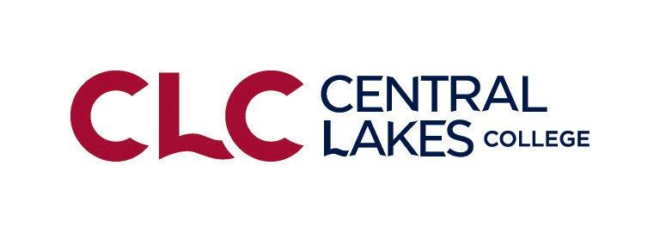
Central Lakes College FBM Suggested Balance Sheet Prices
January 1, 2023 Suggested Balance Sheet Prices for Non-priced Commodities (2022 Analysis Year End)
Crop Suggested Price
Wheat, Spring $9.50/bushel? $9.00 - $10.00
Wheat, Winter $8.07/bushel?
Wheat, Durum $15.00/bushel?
Barley, Feed $6.00/bushel?
Barley, Malting $6.00/bushel ?
Oats $4.50/bushel
Rye $5.00/bushel $4.00-$6.00
Soybeans $14.50 /bushel Range $13.50-$15.50
Corn $5.50/bushel Range $5.00-$6.50
Flax $30.50/bushel?
Canola $36.64/cwt?
Sunflowers, Oil $28.00/cwt
Sunflowers, Confectionary $34.00/cwt?
Beans, Navy $50.00/cwt ?
Beans, Pinto $50.00/cwt?
Beans, Garbonzo $45.00/cwt?
Beans, Black Turtles $35.00-40.00/cwt
Beans, Dark Red Kidney $40-42.00/cwt
Grass Seed, Perennial Rye $105.00 per CWT.?
Grass Seed, Kentucky Blue Grass $150.00 per CWT.?
Grass Seed, Tall Fescue $ 73.00 per CWT.?
Teff Seed $60.00 per CWT.?
Potatoes $10-12.00 per CWT.?
Potatoes, Seed $14.00 per CWT.?
Alfalfa Hay $140.00 -$160.00 for up to 150 RFV add $1.00 for each point RFV over 150 RFV
Mixed hay (Alfalfa/Grass) $ 120.00 Range $110.00 - $130.00
Grass or Small Grain Hay $ 100.00 Range $80.00- $120.00
Peas, Field $.08/lb

Forage and Feed Suggested Prices Per Ton Values
Alfalfa Hay $120.00 -$150.00 for up to 150 RFV add $1.00 for each point RFV over 150 RFV
Mixed hay (Alfalfa/Grass) $ 100.00 Range $90.00 - $120.00
Grass or Small Grain Hay $ 80.00 Range $75.00- $90.00
Oatlage/Other/Peas Convert to dry mixed hay
Small Grain/Sorghum Silage (straight) Convert to dry grass hay or silage
Corn Silage $50.00 $45.00-55.00
Corn Stalk Bales $30.00 per bale ($30-40 per large round bale)
Corn Snaplage convert to corn
Corn $5.00/ bushel
Oats $4.00/ bushel
Straw (Large Bales) $ 90.00/ ton Small square bales $125-140/Ton
Pasture, Well Managed $35/AUM($30-$40)
Pasture, Normal Managed $20/AUM ($15-$25)
Pature, Cover Crop Grazing $35/AUM ($30-$40)
Feeder Steers @ 450lbs $180.00 per CWT Heifers @450lbs $165.00 per CWT
Dairy Feeder Steers $40-$50 per CWT less than beef Heifers-Same
Feeder Steers @ 550lbs $170.00 per CWT Heifers @550lbs $155.00 per CWT
Feeder Steers @ 770lbs $160.00 per CWT Heifers @770lbs $140.00 per CWT
Feeder Steers @ 900lbs $140.00 per CWT Heifers @900lbs $120.00 per CWT
Finished Cattle @ 1350lbs $130.00 per CWT
Finished Cattle, Dairy Cross@1450 $125.00 per CWT
Finished Cattle, Dairy @ 1500lbs $120.00 per CWT
Dairy Bull, Calves $100 per calf
Dairy, Heifer, Calves $80 per calf
Lambs, Slaughter Weight (150-200) $ 120 per CWT $110 - $125/CWT
Lambs, Feeder Weight (70-80) $ 140 per CWT $130-$185/CWT
Weaner, Pigs $ 30 per head
Feeder Pigs, 40 pound ave. $ 55 per Head
Dairy Cows $1200 per head average (1100-1400) (new herd reference)
Dairy Heifers $1400 per head average (1250-1500)
Beef Cows $1000 per head average (900-1100) (new herd reference)
Beef Heifers $1250 per head average (1050-1400)
Hybrid Beef/dairy List as “beef” and value between both beef & dairy
Dairy Goat $500 per head

Organic Production Prices
Organic Corn $9.00/bu
Organic Silage $80.00 - $90.00/ton
Organic Alfalfa Hay $140.00 - $160.00/ton
Organic Mixed Hay $120.00 - $140.00/ton
Organic Soybeans $28.00/bu
Organic Buckwheat $.32/lb $15.36/bu.?
Organic Oats $6.00 - $7.00/bu
Organic Oatlage $55.00 per ton

