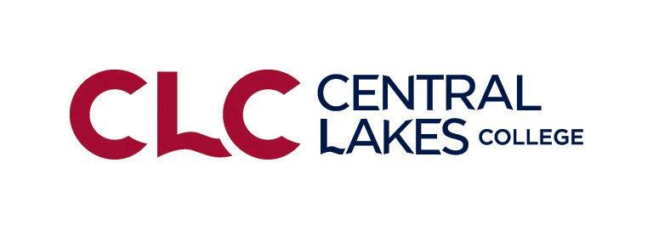
Central Lakes College FBM Suggested Balance Sheet Prices
January 1, 2024 Suggested Balance Sheet Prices for Non-priced Commodities (2023 Analysis Year End)
Crop Suggested Price
Wheat, Spring $7.00/bushel
Wheat, Winter $5.63/bushel
Wheat, Durum $8.75/bushel
Barley, Feed $3.50/bushel
Barley, Malting $5.75/bushel
Oats $3.75/bushel
Rye $5.00/bushel
Soybeans $11.75 /bushel
Corn $4.25/bushel
Flax $11.25/bushel
Canola $21.73/cwt
Sunflowers, Oil $18-21/cwt
Sunflowers, Confectionary $32.00/cwt
Beans, Navy $30.00/cwt
Beans, Pinto $36-38.00/cwt
Beans, Garbonzo $28.00/cwt
Beans, Black Turtles $42.00/cwt
Beans, Dark Red Kidney $42.00/cwt
Grass Seed, Perennial Rye $ 90.00 per CWT.
Grass Seed, Kentucky Blue Grass $160.00 per CWT.
Grass Seed, Tall Fescue $ 90.00 per CWT.
Teff Seed $75.00 per CWT.
Potatoes $11-13.00 per CWT.
Potatoes, Seed $15-15.00per CWT.
Alfalfa Hay $160.00 -$175.00 for up to 150 RFV add $1.00 for each point RFV over 150 RFV
Mixed hay (Alfalfa/Grass) $ 150.00 Range $140.00 - $200.00
Grass or Small Grain Hay $ 130.00 Range $85.00- $200.00
Peas, Field $.08/lb

Forage and Feed Suggested Prices Per Ton Values
Alfalfa Hay $160.00 -$200.00 for up to 150 RFV add $1.00 for each point RFV over 150 RFV
Mixed hay (Alfalfa/Grass) $ 110.00 Range $100.00 - $150.00
Grass or Small Grain Hay $ 100.00 Range $85.00- $150.00
Oatlage/Other/Peas Convert to dry mixed hay
Small Grain/Sorghum Silage (straight) Convert to dry grass hay or silage
Corn Silage $45.00
Corn Stalk Bales $35.00 per bale ($35-40 per large round bale)
Corn Snaplage convert to corn 27bu/ton (dry basis)
Corn $4.50/ bushel
Oats $3.50/ bushel
Straw (Large Bales) $ 100.00/ ton Small square bales $125-140/Ton
Pasture, Well Managed $40/AUM($30-$40)
Pasture, Normal Managed $20/AUM ($15-$25)
Patsure, Cover Crop Grazing $35/AUM ($30-$40)
Feeder Steers @ 450lbs $265.00 per CWT Heifers @450lbs $250.00 per CWT
Dairy Feeder Steers $200.00 per CWT
Feeder Steers @ 550lbs $255.00 per CWT Heifers @550lbs $245.00 per CWT
Feeder Steers @ 770lbs $230.00 per CWT Heifers @770lbs $220.00 per CWT
Feeder Steers @ 900lbs $200.00 per CWT Heifers @900lbs $190.00 per CWT
Finished Cattle @ 1350lbs $150.00 per CWT
Finished Cattle, Dairy Cross@1450 $150.00 per CWT
Finished Cattle, Dairy @ 1500lbs $120.00 per CWT
Dairy Bull, Calves $250 per calf
Lambs, Slaughter Weight (150-200) $ 150 per CWT
Lambs, Feeder Weight (70-80) $ 190 per CWT
Weaner, Pigs $ 45 per head
Feeder Pigs, 40 pound ave. $ 55 per Head
Dairy Cows $1200 per head average (1100-1400) (new herd reference)
Dairy Heifers $1400 per head average (1250-1500)
Beef Cows $1400 per head average (new herd reference)
Beef Heifers $1250 per head average (1050-1400)
Hybrid Beef/dairy List as “beef” and value between both beef & dairy
Dairy Goat $500 per head

Organic Production Prices
Organic Corn $9.00/bu
Organic Silage $80.00 - $90.00/ton
Organic Alfalfa Hay $160.00 - $200.00/ton
Organic Mixed Hay $160.00 - $180.00/ton
Organic Soybeans $19.00/bu
Organic Buckwheat $.32/lb $15.36/bu.?
Organic Oats $6.00 - $7.00/bu
Organic Oatlage $55.00 per ton

